Yunlu Li

STAT 5170

Homework 10

Question 1

(a) AR(5) seems to be appropriate.

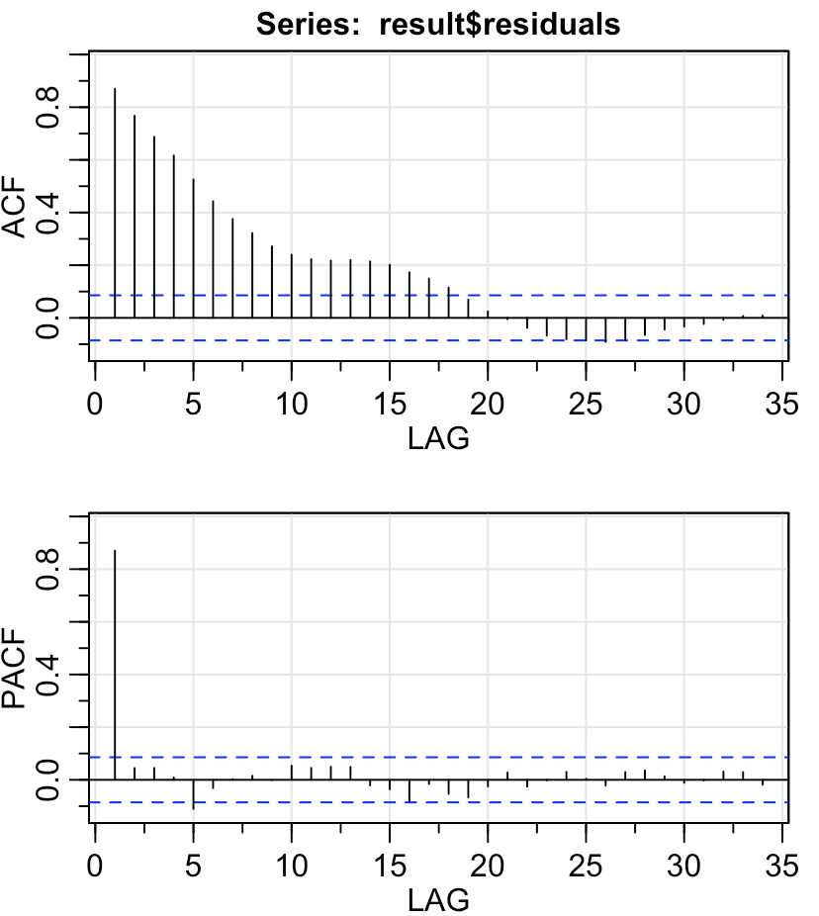

(b) Generally speaking, the model fits the data well. Diagnostics are satisfactory.

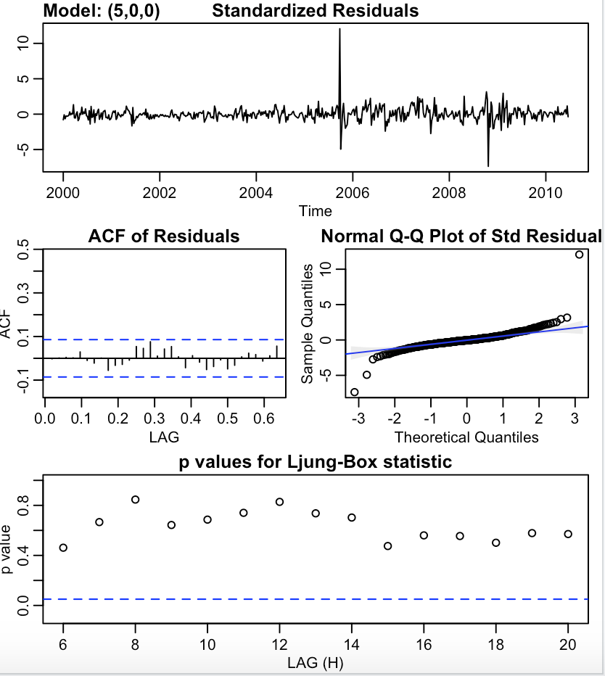

(c) gas=20.8878+2.3212\*oil+ut

where ut=0.8358\*ut-1+0.0186\*ut-2+0.0412\*ut-3+0.0924\*ut-4-0.1102\*ut-5+wt

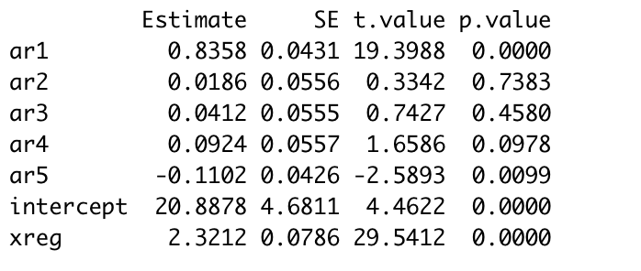

(e) CCP shows significant at lag 0 and insignificant otherwise. We are not regressing on past terms, so a lagged regression is not necessary.

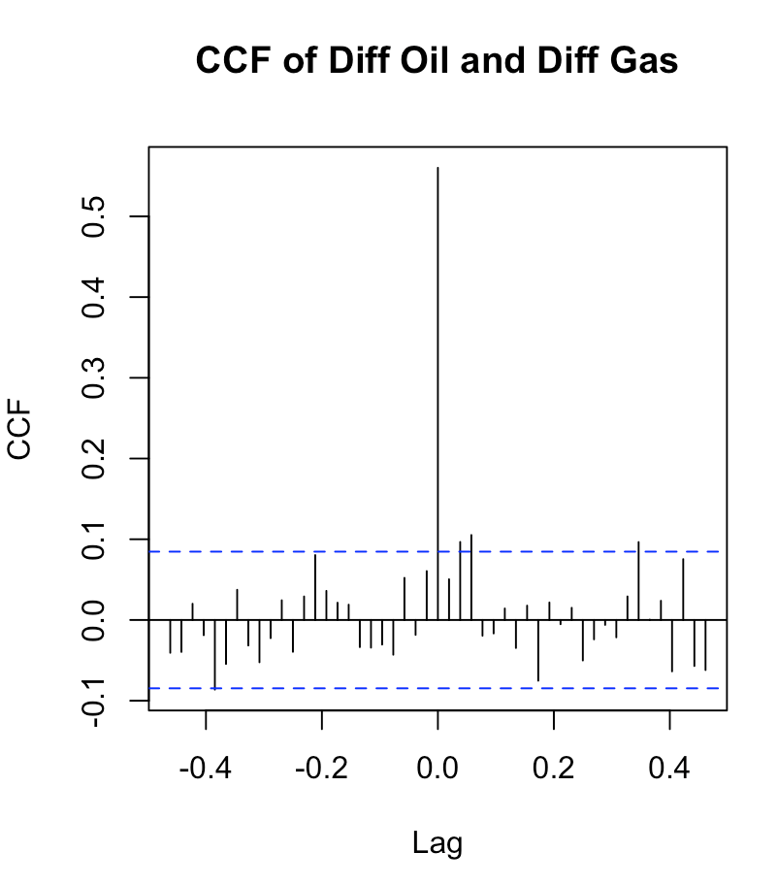

Question 2

(a) Both plots show increasing trend, so they are not stationary.

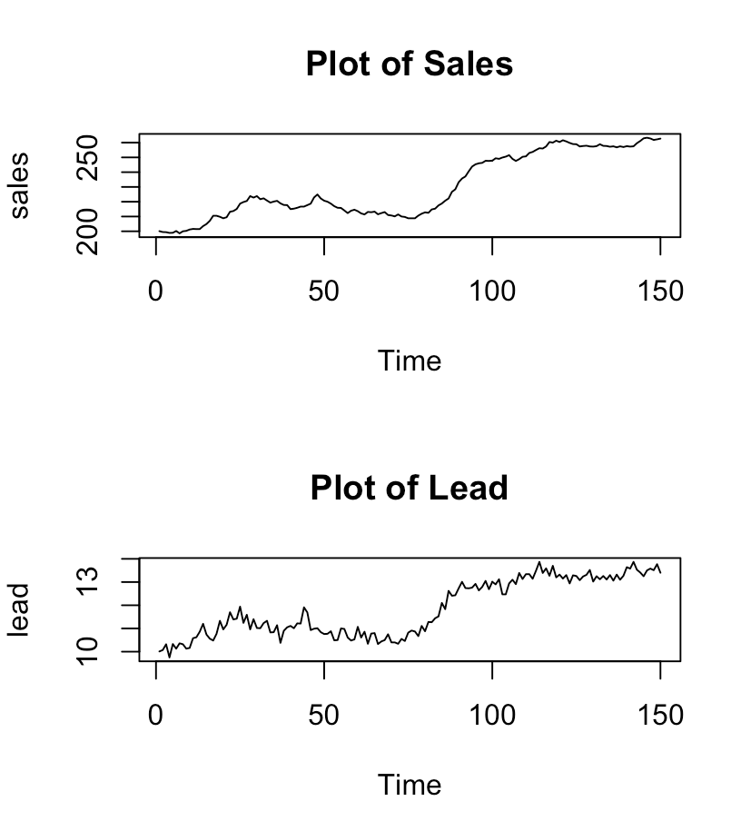

(b) Both subsequent plots are reasonably stationary.

There is no obvious trend and variance are constant.

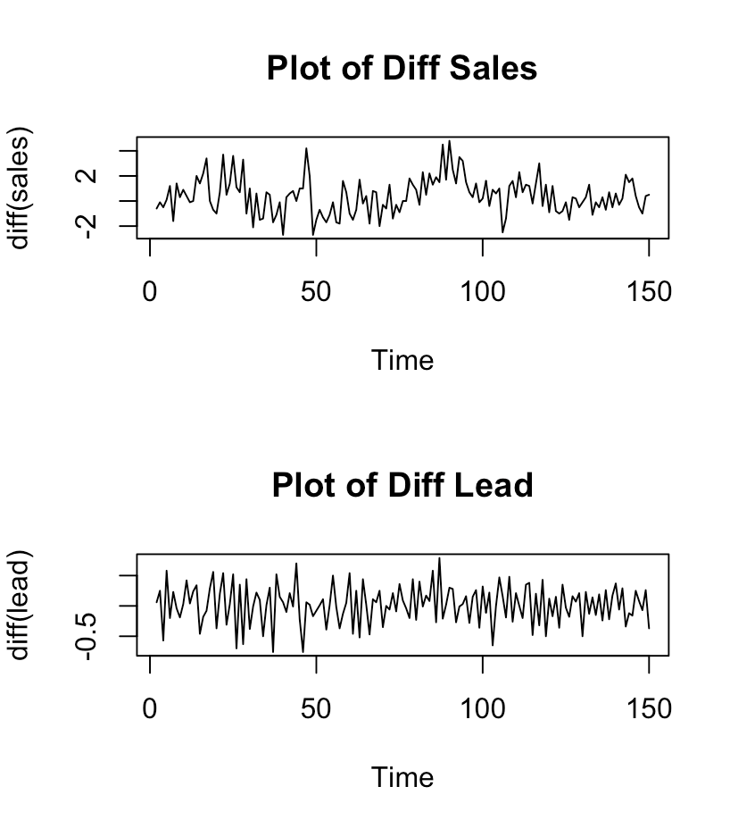

(c) We regress $∇y_{t}$ on $∇x_{t-3}$ and $∇y_{t-1}$

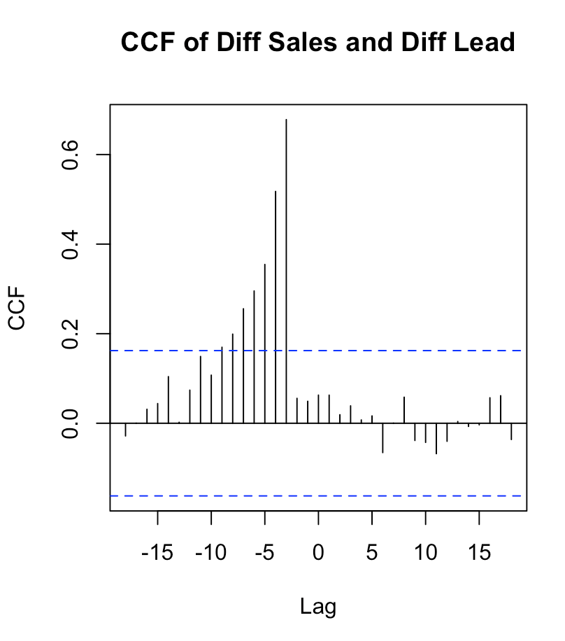

(d) I will consider MA(2).

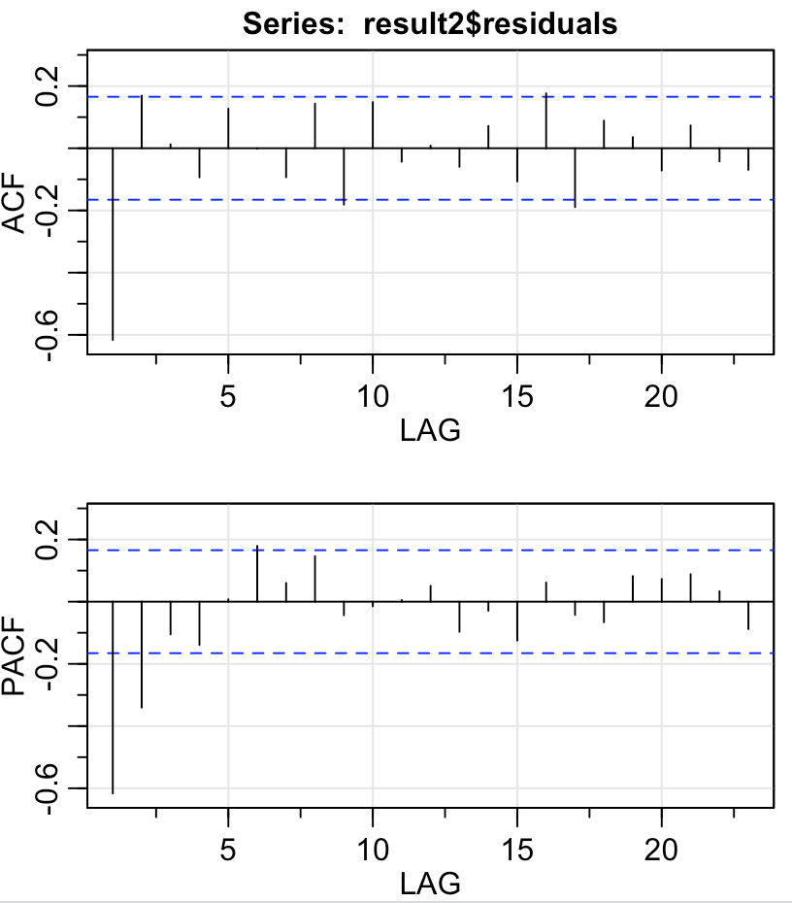

(e) The model fits the data well, passing all diagnostics.

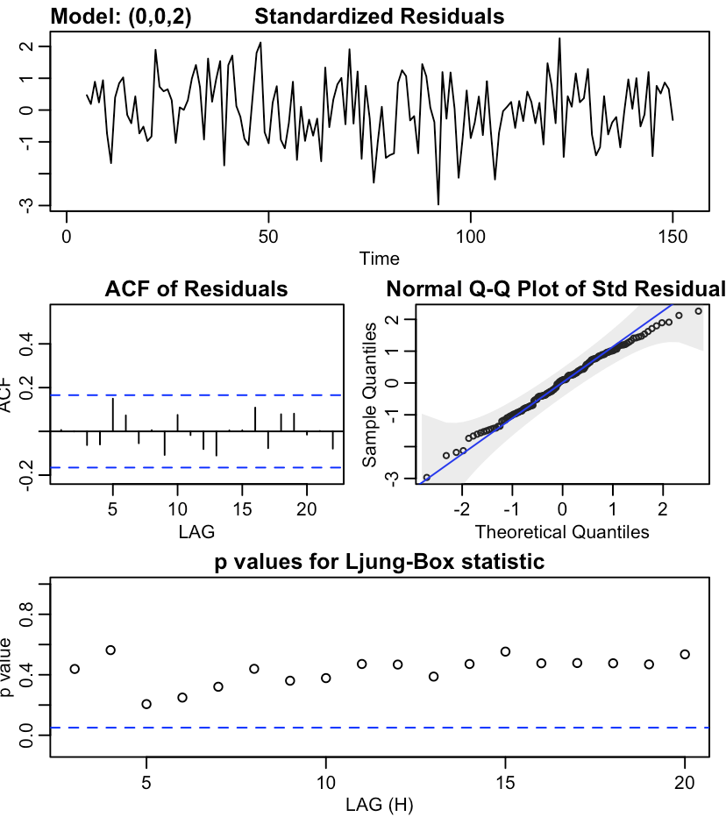

(f) $∇y_{t}=0.0097+4.6985*∇x_{t-3}+0.7258*∇y_{t-1}+u_{t}$

where $u_{t}=0.4236*w_{t-2}-1.3348*w_{t-1}+w_{t}$

